

International Urban & Regional Cooperation Programme (IURC)
in Malaysia

Profiles of Participants
Of Professional Certification
With Laboratory and Workshops:
Green Design and Nature Based Solutions

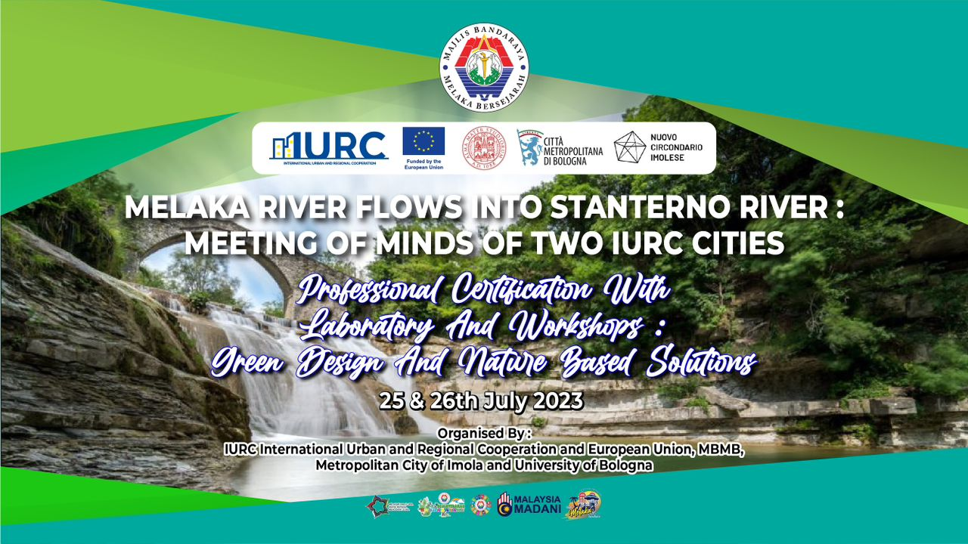
Table of Contents
Melaka Participants
- TPr. Zuhaila Ahmad Zubel
Town Planning Director of Melaka Historic City Council
- Ms. SITI Asurah bt. Mohd Gani
Assistant Director of Engineering Department
of Melaka Historic City Council
- LAr. Mohammad Faizdzul SHAWQY Ibrahim

Landscape Architect of Melaka Historic City Council
- Ms. ROHZAINA Zainal

Assistant Director of Town Planning Department

(Green Technology & Smart City) of Melaka Historic City Council
- Ms. SYAFRINA Md Yusop

Assistant Director (Media) of Corporate Department

of Melaka Historic City Council
- Ms. NORHASZURAH Md Daud

Assistant Director of Town Planning Department

of Melaka Historic City Council
- Mr AMER Aiman Yahya

Assistant Director of Landscape Department

of Melaka Historic City Council
- Ms. Nurul FITRAH Jaafar

Management Trainee of Town Planning Department

of Melaka Historic City Council

Dr. Muhammad Adam Che Yusof
Senior Lecturer in Department of Town and Regional Planning,
College of Built Environment, Universiti Teknologi MARA (UiTM)

Tpr. ZUHAILA Ahmad Zubel

Director of Town Planning, Melaka Historic City Council

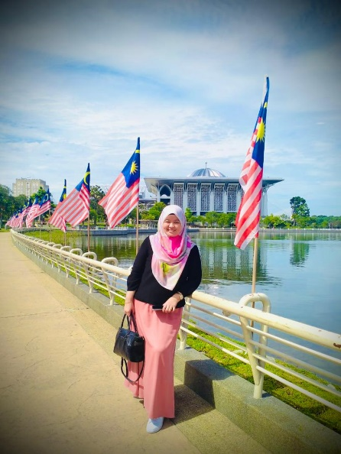
TPr. Zuhaila graduated from Malaysia University of Technology in 2006. She started her first professional Town Planner practice at ZMD Planning Consult for 3 years. In February 2009 she serves as Town Planner at MBMB and in 2020 she appointed as a Director of Town Planning Department. With an outstanding achievement and her Excellency in Town Planning she rewarded her professional title as Registered Town Planner early 2021.

Languages : Malay is his mother tongue and fluent in English

Hobbies : Cooking, travelling.

Ms. SITI Asurah bt. Mohd Gani

Assistant Director of Engineering Department of Melaka Historic City Council

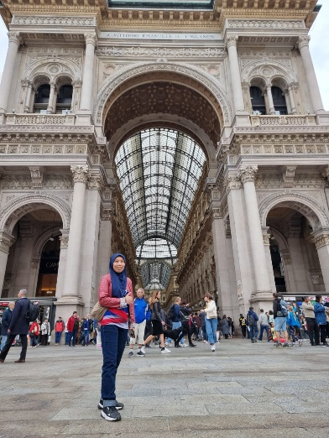
She graduated from Malaysia Technology University in Bachelor Of Civil Engineering. A member of Institute Of Engineer Malaysia, and recognise as Civil Engineer by Board Of Engineer Malaysia. Started as Engineer in Melaka Historic City Council in 2002. She has over 20 years’ experience in various civil field such as Building Maintenance, Infrastructure Works, Community Management, Sewerage Treatment Plants, Logistics, Project Management, Heritage Building & Monument Maintenance.

Active in sports, travelling, reading, hiking, cycling, photography, astronomy, food hunter, architecture, forensic engineering.

LAr. Mohammad Faizdzul SHAWQY Ibrahim

Landscape Architect of Melaka Historic City Council

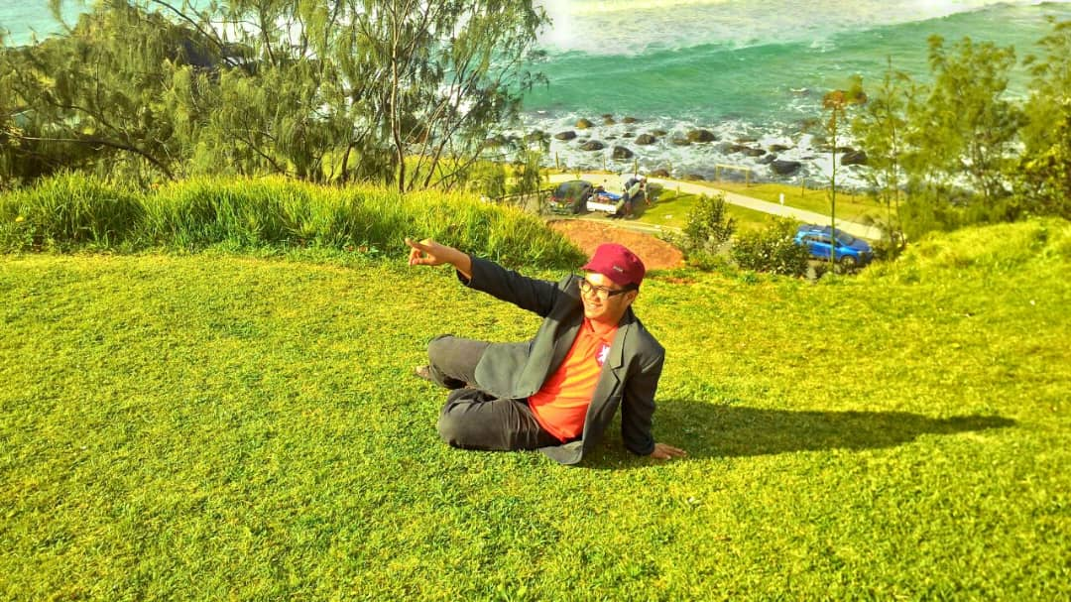

LAr. Mohamad Faizdzul Shawqy bin Ibrahim graduated from Malaysia University of Technology in 2013. His first professional Landscape Architect practice is at Verona Design Sdn Bhd for 1 year. During his practice in the firm, he is involved in designing for a wide range of project aspects with different disciplines, including park and open space design, urban regeneration schemes, pedestrian schemes, streetscape schemes, and preserving the character of sites and natural beauty. In September 2013, he serves as Landscape Architect at MBMB and in 2018 he gained his professional title as Registered Landscape Architect (LAr.) ”

Languages : Malay is his mother tongue and fluent in English

Passion and hobbies: Innovation, Landscape Architecture, Architecture, Photography, Mathematics, Motorsports

Ms. ROHZAINA Zainal

Assistant Director of Town Planning Department (Green Technology & Smart City) of Melaka Historic City Council

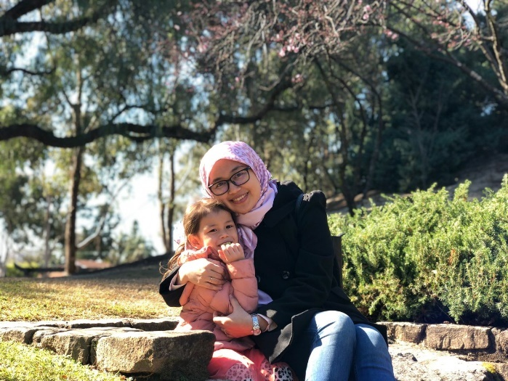

Ms. Rohzaina was born on 27 August 1984, and raised in Melaka city. She had her schooldays in an historic little town called Tranquerah. She holds a Bachelor in Electronics Engineering (Industrial Electronics) with honours from University of Technical Malaysia Melaka in 2009. She is accredited in NCS Green Compliance and a Certified Energy Manager.

She started working as an process engineer right after finish her final year examination with global company, Sony Electronics Malaysia for 3 years. She stepped into government serving in year 2013 as an Electrical Engineer and starting year 2019 she shifted her scope in Green Technology and Smart City.

Among significant projects during her career are; installation (retrofit) of Smart LED streetlight in Melaka City which this is the first in Malaysia, among the pioneer city council that implement fabric recycling programs, organizing annual celebration of WWF famous Earth Hour, developing Low Carbon Zone in Peringgit Hill Melaka, active in supporting local communities in urban edible garden, and get to be in the technical team which developing National Action Plan such as Smart City Malaysia Masterplan and Low Carbon City Masterplan, Melaka State Action Plan such as Melaka Sustainable Report and Melaka Smart City Action Plan, and a global level action plan which is Resilient Melaka under The Rockefeller Foundation – 100 Resilient Cities. Her latest ongoing project are providing green energy via solar pv for the electric scooter which is used by the city council enforcement officer which is a component under Smart Mobility MBMB Project, Banda Hilir Car Free Zone and developing Smart and Low Carbon City Action Plan MBMB 2035.

Her guide to life:
“Always pray. It is the most powerful tool against worry, doubt and fear.”

Passion and hobbies: Reading motivational and parenting books, listening to Ludovico Einaudi, recycling and zero-waste movements and activities, running, camping with family, plogging with the kids.

Ms. SYAFRINA Md Yusop

Assistant Director (Media) of Corporate Department of Melaka Historic City Council

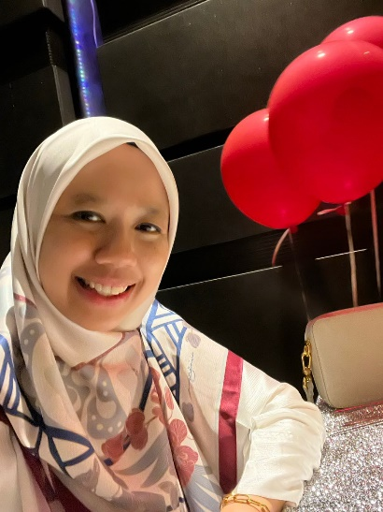
Graduated from University Of Malaya and Degree holder of Applied Geology. She has 2 years experience at civil Engineering company , Institut Kerja Raya Malaysia (IKRAM) and 9 years experience as administrative officer at Melaka Historic City Council . Currently she works at Corporate Department as Media Officer.

Ms. NORHASZURAH Md Daud

Assistant Director of Town Planning Department of Melaka Historic City Council
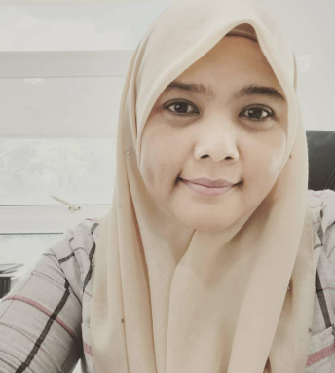
She was born on June 24, 1977 and raised in Melaka. She graduated with a Diploma in Town and Regional Planning from Universiti Institut Teknologi Mara in 1999 and a Degree in Town and Regional Planning from Universiti Teknologi Malaysia in 2019. Started her service at the Melaka Historic City Council in 2001 until now and has 20 years of expertise in the success of GIS work for the Town Planning Department, MBMB. Her expertise involved in Geographical Information System (GIS), MBMB Local Plan and Planning Permission in urban planning for the Melaka Historic City Council. Languages : Malay is her mother tongue and fluent in English. Hobbies: Reading, looking at the sky and sunset.

Ms. Nurul FITRAH Jaafar

Management Trainee of Town Planning Department of Melaka Historic City Council

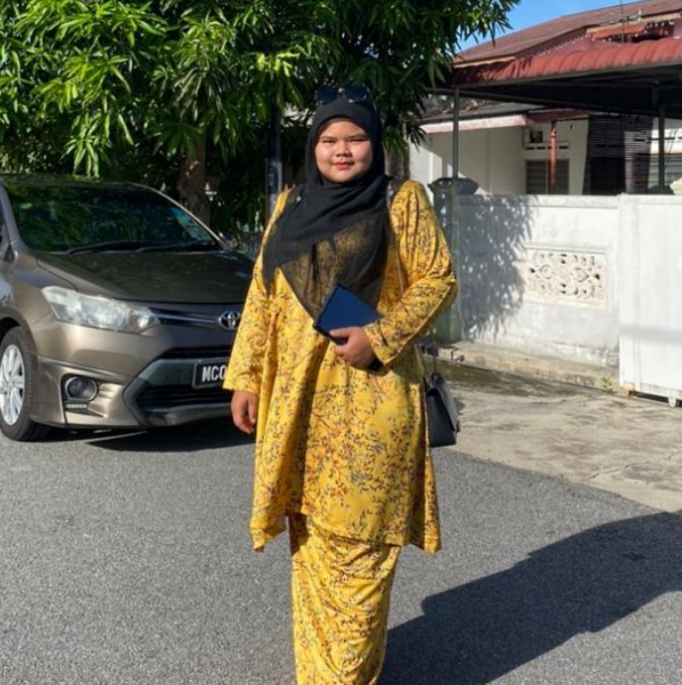

Nurul Fitrah is an accomplished urban planner graduates with a passion for creating resilient and sustainable city development. She graduated in November 2018 with a Bachelor of Urban and Regional Planning (Honors) from International Islamic University Malaysia (IIUM), laying the foundation for her remarkable career in the field of urban development. Upon completing her studies, Nurul Fitrah wasted no time in making a meaningful impact in her chosen profession. In January 2019, she embarked on her journey at Melaka Historic City Council. Over the course of five years, she demonstrated her expertise in resilient development, proving to be a valuable asset to the organization. Recognized for her exceptional dedication to promoting resilience within her community, Nurul Fitrah was appointed as the Resilient Champion in 2019. This role allowed her to develop and inspire colleagues and fellow community towards a more sustainable and secure future. Winning awards like the Malaysian Institute of Planners Excellence Award (MIPPEA) 2022 - Bronze Winner for Resilient Melaka and the Commonwealth Association of Planners Award 2022 - Winner for Planning for the Climate Emergency is a testament to her outstanding contributions in the field of urban planning and climate resilience. Nurul Fitrah's contributions to the development of Melaka's Resilience Strategy have been pivotal. She played a role in the preparation and implementation of both the Melaka Resilient Strategy 1.0 and its subsequent 2.0 version. Additionally, her expertise extended to several other vital projects, including the Green Transportation Integrated Masterplan, Heritage Area Integrated Masterplan, Urban Ocean for Sustainable Waste Management, Ceritera Melaka initiative to preserve the Melaka tangible and intangible heritage element, the Catalyzing City Resilience Solutions for Small Medium Enterprises (SMEs) Empowerment, Global Risk and Resilience Fellowship and Urban Climate Resilience – Resilience for Community (R4C). Throughout her career, Nurul Fitrah has demonstrated a strong drive to create positive change and enhance the resilience of communities. Her innovative approach to urban planning, coupled with her dedication and determination, has earned her widespread recognition in the field. As she continues to contribute her knowledge and expertise to the sustainable development of urban areas, Nurul Fitrah remains committed to building a resilient and environmentally conscious future for generations to come. Life aphorisms “Persevere in giving and adhere the power of the Almighty”.
Dr. Muhammad Adam Che Yusof
Senior Lecturer in Department of Town and Regional Planning, College of Built Environment, Universiti Teknologi MARA (UiTM)

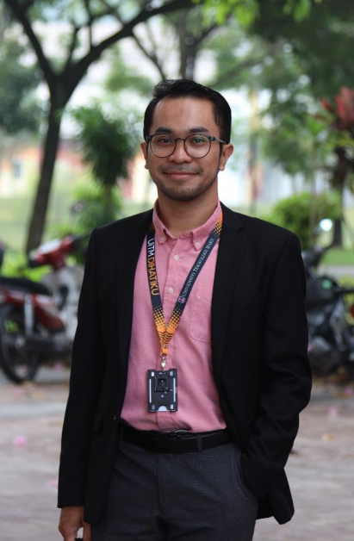

Dr. Muhammad Adam bin Che Yusof was born on 20 December 1990. A senior lecturer in Department of Town and Regional Planning, College of Built Environment, Universiti Teknologi MARA (UiTM), Puncak Alam, Selangor with specialization in Heritage Conservation and Urban Design. He holds a Doctor of Philosophy (PhD) in Building Conservation from Universiti Sains Malaysia (USM) and had been to several conferences and workshops during his study. He was selected to collaborate with Kyushu University in Fukuoka, Japan for a 2 weeks programs of Environmental Design Global Hub Symposium with other 10 participants and universities from around South East Asia countries. He was also a town planner that involved in both strategic planning and master planning projects during his career in industry sectors. Among the projects involved was Majlis Perbandaran Alor Gajah Local Plan (RTMPAG); Kuala Kangsar Local Plan (RTKK); masterplan layout and development proposal for industry, housing, mixed development and medical city for different stakeholders. A member of Malaysian Institute of Planners (MIP) and Malaysia Board of Technologists (MBOT), he is also part of the team for special project; My Heritage School with ICOMOS Malaysia since 2021. Other than that, he is currently involve in a team of expertise for dilapidation study for Muzium Senibina Malaysia in Melaka, collaboration with Jabatan Warisan Negara (JWN). Languages: Fluent in Bahasa Malaysia and English Causes: Social services, animal welfare, conservation, environment, humanitarian relief, art and culture Passion and Hobbies: running, hiking, watching movies, sketching, collecing toys, community service

Mr AMER Aiman Yahya

Assistant Director of Landscape Department of Melaka Historic City Council

